**Inter VLAN Routing**

**What is inter Vlan routing?**

Inter-VLAN routing is the process of enabling communication between devices located in different VLANs (Virtual Local Area Networks).

Why we use inter vlan routing?

* Enable communication across VLAN’s
* Improve network security
* Efficient Resource Sharing
* Optimizing Traffic Management
* Scability

**Example :** In a university network system

* VLAN 10 is for Students
* VLAN 20 is for Faculty
* Vlan 30 is for Authority

Faculty might need access to Student’s share files, and both might need Authority. Inter-VLAN routing makes this possible while maintain logical separation and security.

**Required devices:** layer-2 switch, layer-3 switch, Laptop/Personal-Computer

**Network Architecture:**

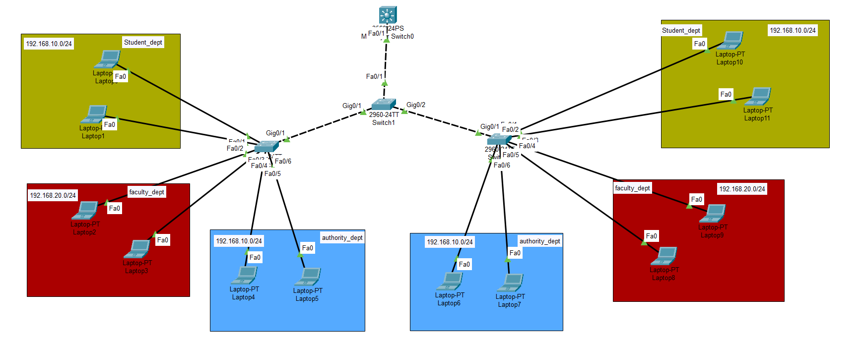

**Create VLAN & VTP :**  Create and configure Vlan and vtp in layer-2 switches.

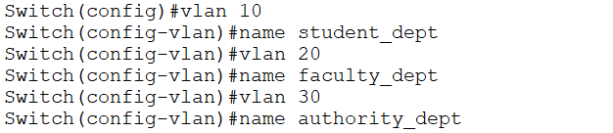

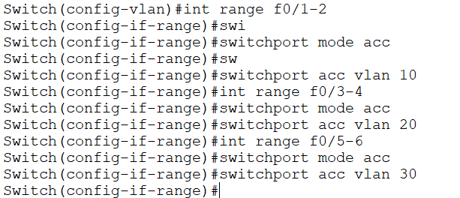

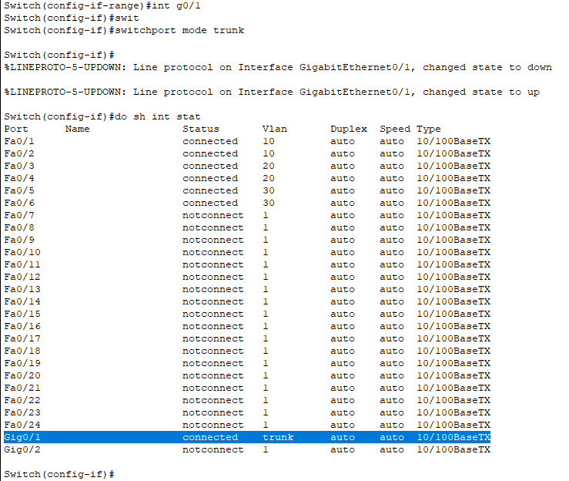

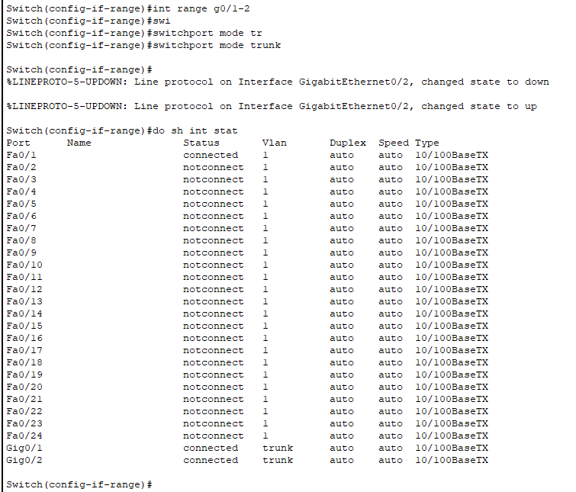

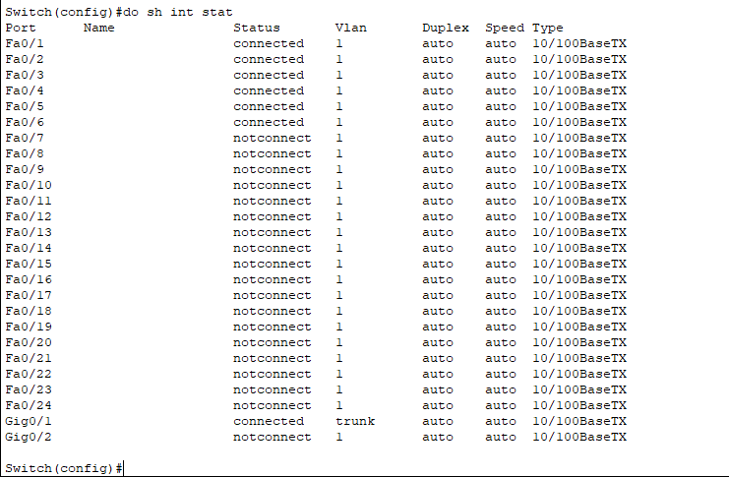

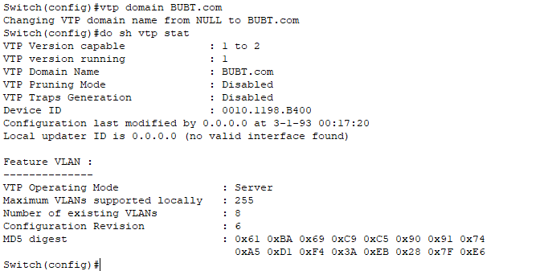

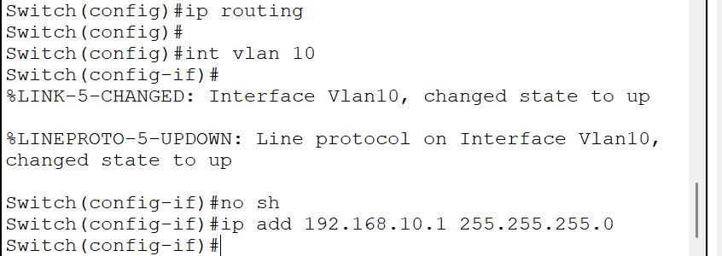

**\*\*\* Assign the port with VLAN in the right layer-2 switch\*\*\***

**Configure Layer-3 switch(Multi-layer Switch):**

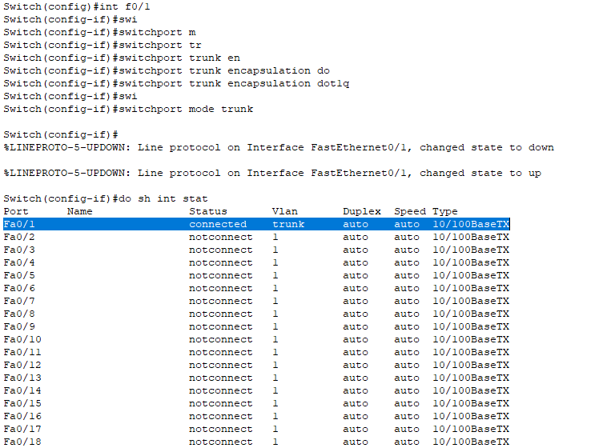



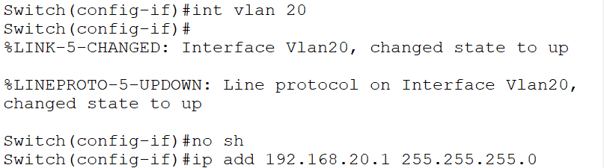

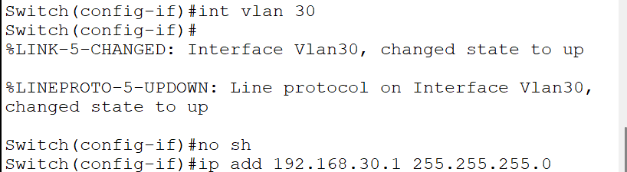

**Show the ip addresses those are configured in the VLAN’s**

**(Show interface status)**

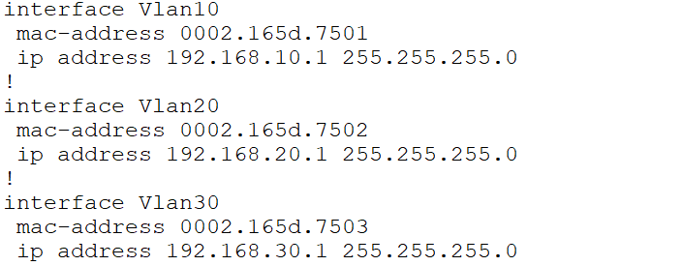

**Final output:**

